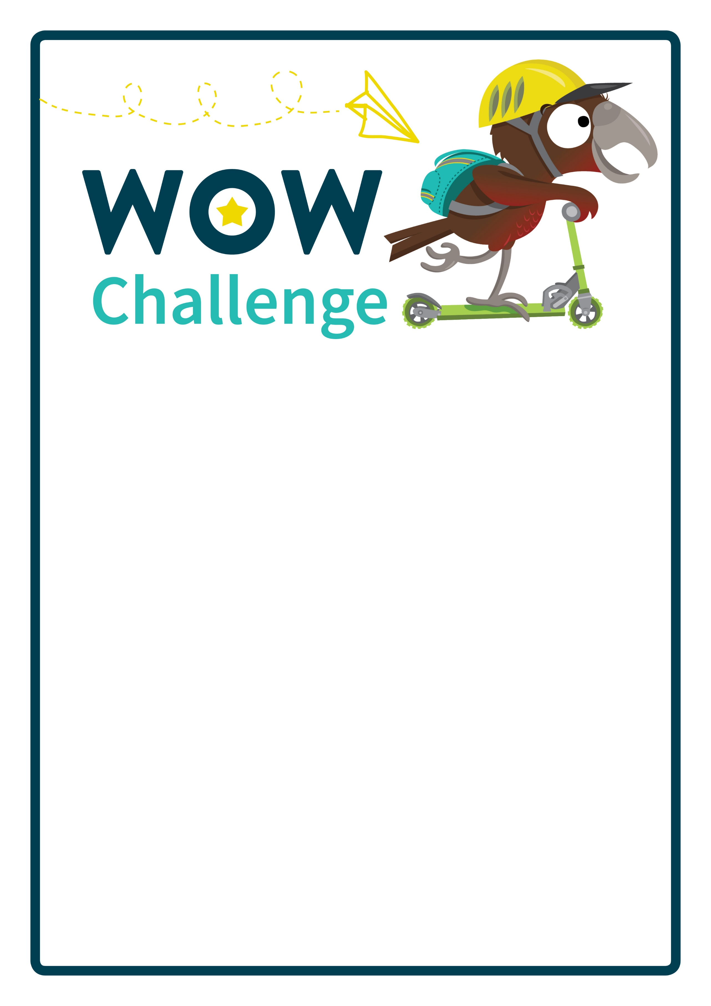

Write details of the WOW Challenge here….